B39SB Time and Frequency Signal Analysis – Tutorial 5

P1. Two LTI systems are arranged in series with and . Find the impulse response of the entire system.

Solution. .
Therefore .

P2. An active filter has the transfer function . For what values of k is the filter stable?

Solution. For the circuit to be stable, the poles must be located in the left half of the s plane. This implies that or .

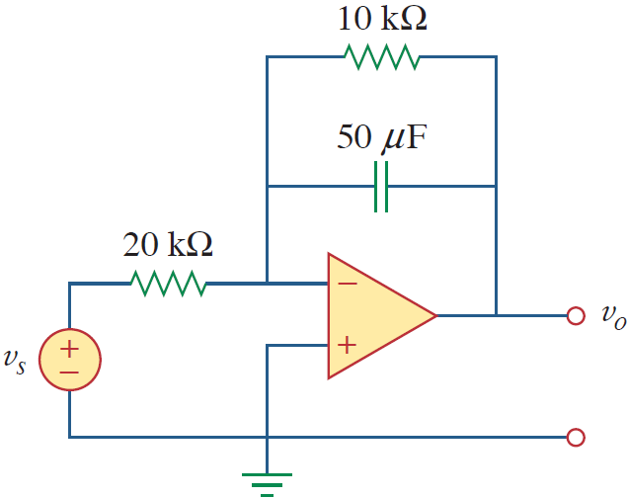
P3. (from Alexander-Sadiku textbook) . Find for .

Solution. Nodal analysis yields
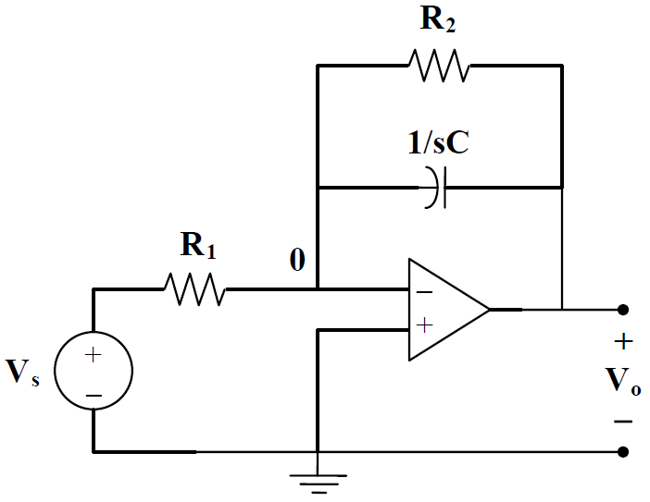

P4. The transfer function of a circuit is given by . Find the output when
(a) the input is 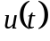; (b) the input is .

Solution. (a) We have

(b)

P5. (from Alexander-Sadiku textbook) Find .
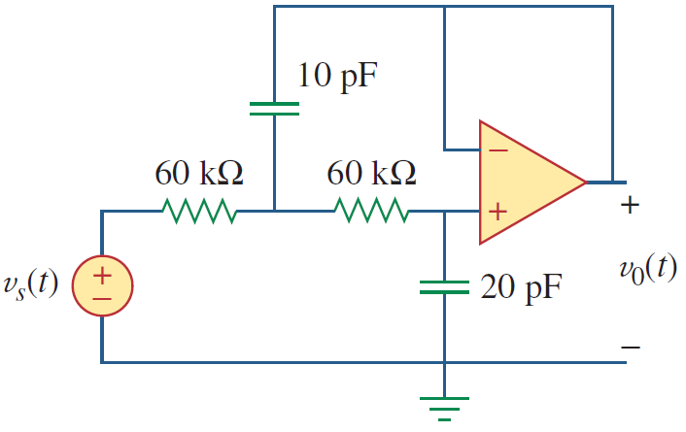

Solution. We use nodal analysis.
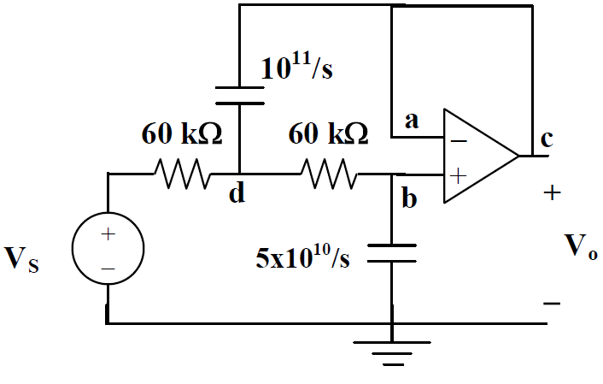 | Let us write KCL equations at nodes b and d.

